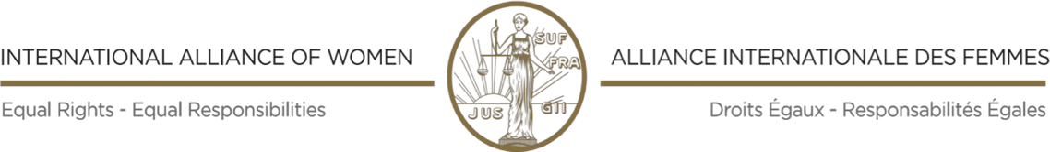

MEDIA CONTACT
Lene Pind
email: lenepind@gmail.com
mobile: +45 81 11 60 07

PRESS RELEASE

THIRTY-EIGHTH IAW CONGRESS
November 24-26, 2020

No. 02 Nov. 24. 2020

"CARING ECONOMY: PUTTING PEOPLE OVER PROFITS"

Today IAW's first-ever virtual Triennial Congress in its 116 years of history started with 67 participants from around the globe.

In her opening speech on the theme of the Conference, Joanna Manganara, IAW President, reiterated the urgent need for systematic change to Caring Economy by Putting People over Profits. According to her, in the midst of the COVID-19 crisis, it has become obvious that patriarchy (and other failed concepts of neoliberal economy) with attendant exploitation and devastation, is not compatible with Equality, Human Rights and Peace. There is no legitimacy for war, hunger, devastation against people and the planet for the profit of only a few. These are crimes which risk all our health, humanity and the planet. For the recovery, 50 percent of global military expenditures should be reallocated to global health expenditures.

The next endeavor is to end war. In this wise, IAW fully supports and recalls the United Nations Secretary General's call for a Global Cease Fire. It is not acceptable that members of the UN Security Council disregard the core task of peacekeeping and the will of millions of peace builders to end war. Women are ready to build a force for 50 percent participation in all peace negotiations and processes. There cannot be a track 2 or track 3 anymore.

According to Lyda Verstegen, Honorary President, IAW, "The ILO Convention 189 Concerning Decent Work for Domestic Workers …needs be ratified by all UN member states. This would improve -mainly female -domestic workers' labour rights and working conditions globally, especially in consideration of the overlap with human trafficking." Protection against all forms of gender-based violence, as provided by the binding Istanbul Convention, should be given top priority.

To ensure women's human rights to reproductive health, contraception should be affordable and accessible everywhere to both women and men. In this regard, IAW expresses its solidarity with Polish women and all LGBTIQ globally.

Joanna Manganara Olufunmi Oluyede
President Secretary-General

IAW on Twitter: #IAWCongress2020, #CaringEconomy, #PuttingPeopleOverProfits, #Feminist

President. Executive Treasurer Secretary-General
Joanna Manganara Vice Presidents Antonia Lavine, USA Olufunmi Oluyede, Nigeria
Greece. Ruhi Sayid, Pakistan Assistant Secretary-General
Natalie Kostus, Poland T. Miranda Ruzario, Zimbabwe

iawpres@womenalliance.org iawtreas@womenalliance.org iawsecgen@womenalliance.org

www.womenalliance.org
IAW/IAF is in consultative status, general category, with the United Nations Economic and Social Council, enjoys participatory status with the Council of Europe and is a member of the European Women’s Lobby

